P30 EAB Annual Meeting Agenda* August 14, 2017
(*All times listed below are EST. )

12:45 – 1:00 pm Video conference setup (CVS Room, Salk Pavillion, 335 Sutherland Dr.)
(Light refreshments will be served.)
1:00 – 1:15 pm Welcome by CDAR Center Director Dr. Xiang-Qun (Sean) Xie

Randall Smith, PhD, Professor and Senior Associate Dean, School of Pharmacy, University of Pittsburgh

Xiang-Qun (Sean) Xie, PhD, Director of CDAR Center & Professor and Associate Dean, Department of Pharmaceutical Sciences & Drug Discovery Institute, Department of Pharmaceutical Sciences, School of Pharmacy, University of Pittsburgh

1:15 – 3:30 pm CDAR Core Research Reports by Core PIs (all team members invited)
1:15 – 1:45 pm AdminCore Report: Training, Dissemination and Administration by Dr. Terry McGuire

1:45 – 2:20 pm Core A Report: “Computational Chemogenomics & Systems Pharmacology for
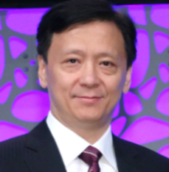
Drug Abuse and Neurodisorder Research”
by Xiang-Qun (Sean) Xie, MD, PhD, EMBA (Core A), Professor and Associate Dean, Department of Pharmaceutical Sciences & Drug Discovery Institute, Director of CDAR Center (25 + 10 min Q/A)

2:20 – 2:55 pm Core B Report: “Computational Molecular & Systems Pharmacology for
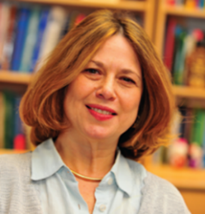
Neurobiological and Drug Abuse Research”
by Ivet Bahar, PhD (Core B), Distinguished Professor & JK Vries Chair, Department of Computational & Systems Biology, Associate Director of University of Pittsburgh Drug Discovery Institute (25 + 10 min Q/A)

2:55 – 3:30 pm Core C Report: “Understanding Drug Abuse Using Deep Machine Learning
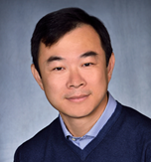
Approaches”
by Eric Xing, PhD (Core C), Professor, Machine Learning Department & Language Technology Institute & Computer Science Department, Associate Department Head of the Machine Learning Department, Carnegie Mellon University (25 + 10 min Q/A)

3:30 – 5:00 pm Break (10 min) and Skype Meeting of EAB Members Only (Chaired by Dr. Nurulain Zaveri)

5:00 – 6:00 pm Meeting of EAB members with the CDAR Leadership

5:45 – 6:30 pm Pizza (available for Core PIs, their assistants, and EAB members present)

